Test tool validation protocol

Document revisions
Date | Person | Changes
12/01/14 | Philippe Steinmann | Creation
14/01/14 | Philippe Steinmann | Added Test node part

Introduction
Multi diag tools library is based on unit testing.
For the “Test tool” part, it was chosen to check the software with a realistic scenario. Later, tests that can be automated will be added as unit tests.
To execute a test, please copy this document or print it.

Scenario
We will use a existing vehicle type for this scenario, but exposed schema are deliberately wrong.

Vehicle
Let say that we have to work on a RBDe 560 DO vehicle type.
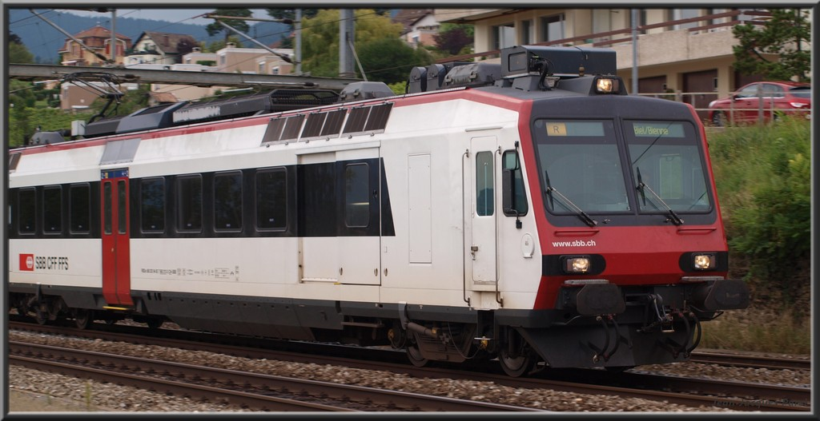
The RBDe 560 DO is a RBDe 560, as DOMINO variant. We consider that we work on first series.

Vehicle schema
Here is the schema of the RBDe 560 DO. Of course, it is 100% fake !
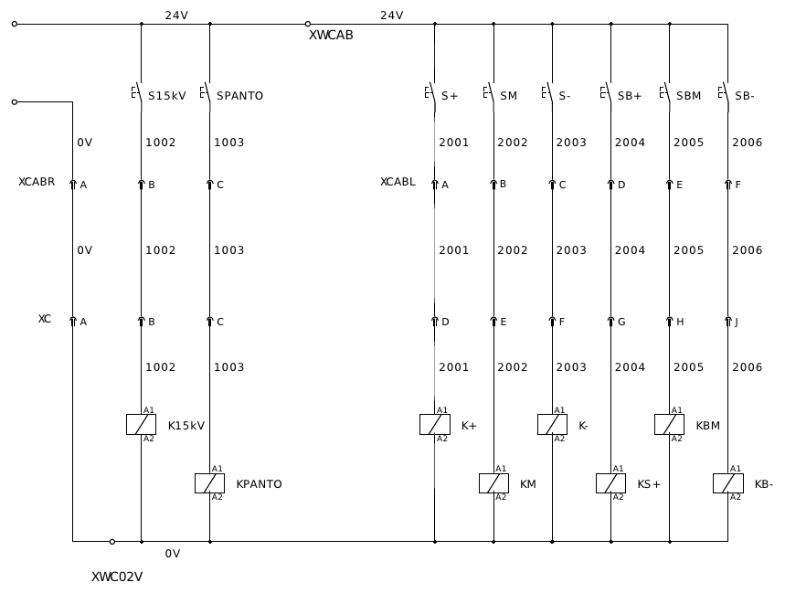

Tests
We have to check the cable that links CABR and CABL with CONTROL cabinets.
Schema of coupling box, page 1
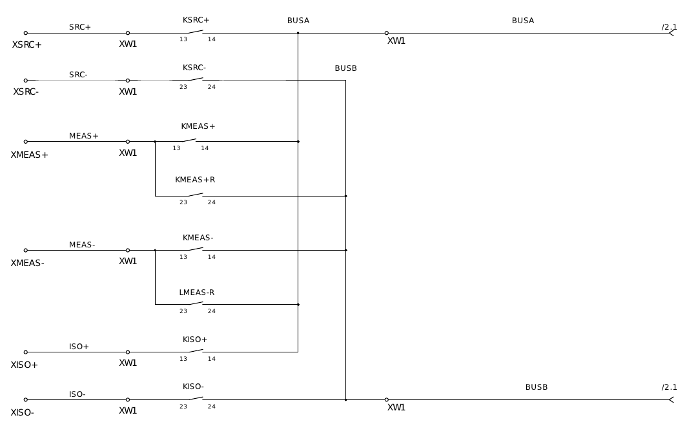

Schema of coupling box, page 2
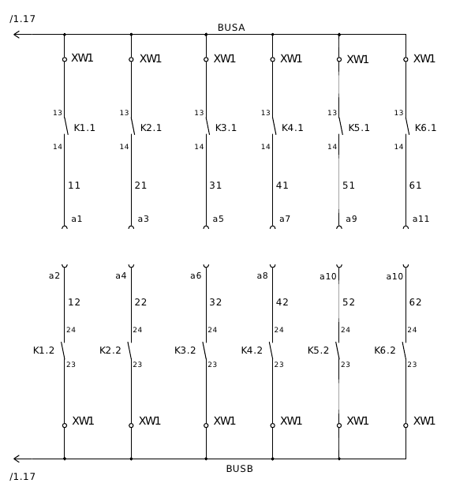

Test protocol

Database creation
# | Designation | Ok | Nok
1 | Creation of new database works
2 | Filename received a correct extension

Remarks:
….........................................................................................................................
….........................................................................................................................
….........................................................................................................................
….........................................................................................................................

Vehicle type

GUI coherence by empty table
This check is done once, because all editors are using same subsystem.
# | Action | Expected result | Ok | Nok
1 | Just open vehicle type edition form by a freshly new created database. | All main widgets are disabled (line edit, ...)
2 | -- | All child tables are disabled
3 | -- | “New” action is enabled
4 | -- | “Save” action is disabled
5 | -- | “Cancel” action is disabled
6 | -- | “Delete” action is disabled
7 | -- | Navigation is disabled
8 | Call “New” action | All main widgets are enabled (line edit, ...)
9 | -- | All child tables are disabled
10 | -- | “New” action is disabled
11 | -- | “Save” action is disabled
12 | -- | “Cancel” action is enabled
13 | -- | “Delete” action is disabled
14 | -- | Navigation is disabled
15 | Edit (in main widget) | All main widgets are enabled (line edit, ...)
16 | -- | All child tables are disabled
17 | -- | “New” action is disabled
18 | -- | “Save” action is enabled
19 | -- | “Cancel” action is enabled
20 | -- | “Delete” action is disabled
21 | -- | Navigation is disabled
22 | Calle “Save” action | Save works
23 | -- | All main widgets are enabled (line edit, ...)
24 | -- | All child tables are enabled
25 | -- | “New” action is enabled
26 | -- | “Save” action is disabled
27 | -- | “Cancel” action is disabled
28 | -- | “Delete” action is enabled

Functions check
# | Designation | Ok | Nok
1 | Vehicle type add works
2 | Vehicle type edition works
3 | Vehicle type deletion works

Remarks:
….........................................................................................................................
….........................................................................................................................
….........................................................................................................................
….........................................................................................................................

Connectors
We choose following connectors:
- XCABR, Cab side: ITT Corporation, 5p female, type CA3106E14S-5SB-A240
- XCABR, cable side: ITT Corporation, 5p male, type CA3106E14S-5PB-A240
- XCABL, cab side: ITT Corporation, 10p female, type CA3106E18-1SB-A240
- XCABL, cable side: ITT Corporation, 10p male, type CA3106E18-1PB-A240
- XC, control unit side: ITT Corporation, 17p male, type CA3106E20-29PB-A240
- XC, cable side: ITT Corporation, 17p female, type CA3106E20-29SB-A240
Contacts are named:
- 5p: A, B, C, D, E
- 10p: A, B, C, D, E, F, G, H, I, J
- 17p: A, B, C, D, E, F, G, H, J, K, L, M, N, P, R, S, T
# | Designation | Ok | Nok
1 | Connector creation works
2 | Connector edition works
3 | Connector deletion works
4 | Contact creation works
5 | Contact edition works
6 | Contact deletion works

Article and article connection
Here, we suppose that relays K15kV and KPANTO are Elesta, type SKR115A 24VDC, witch needs a socket from Elesta, type ZKE 118.
For other relays, we take Finder type 55.32.9.024.0040, with socket type 94.04SPA.
For each relay, we create a article (relay + socket), then we create a other witch has relay and socket as component.
Again, this are all fake values.
# | Designation | Ok | Nok
1 | Article creation works
2 | Article edition works
3 | Article deletion works
4 | Adding connection works
5 | Editing connection works
6 | Removing connection works
7 | Component assignation works

Remarks:
….........................................................................................................................
….........................................................................................................................
….........................................................................................................................
….........................................................................................................................

Article link
To be done...

Unit, unit connection and vehicle assignation
Take articles created before, and add them regarding schema.
# | Designation | Ok | Nok
1 | Unit creation works
2 | Unit edition works
3 | Unit deletion works
4 | Article based unit creation works
 | Setting a base article by unsaved new unit gives a correct message
 | Base article selection is correctly presented (size, columns, ...)
 | Adding free connection works
 | Adding article based connection works
 | Editing connection works
 | Removing connection works
 | Component assignation works (to be done) | -- | –
 | Vehicle assignation works
 | Removing vehicle assignation works
 | When saving a unit with no vehicle type assigned, a warning is generated

Remarks:
….........................................................................................................................
….........................................................................................................................
….........................................................................................................................
….........................................................................................................................

Unit link
Add links regarding schema.
# | Designation | Ok | Nok
1 | Link creation works
2 | Link edition works
3 | Link deletion works
4 | The function “View path” shows coherent paths
5
6
7
8
9 |  | -- | --

Remarks:
….........................................................................................................................
….........................................................................................................................
….........................................................................................................................
….........................................................................................................................

Test node edition
To check the cable linking CABR, CABL and CONTROL cabinets, we have a coupling box.
The test system is named “Cable checker”. All relays are Wago 750-513 modules.
# | Action | Expected result | Ok | Nok
1 | Add a vehicle type named cable checker, variant named Coupling box. This is the 1st series. | Creation works
 | Open test node editor, and create a test node based on freshly created vehicle type.  Node ID: 1 | Vehicle type assignation is not possible until the new test node was created (GUI coherence)
 | -- | Assignation of vehicle type works
 | – | Edition and saving works
 | Add a article for Wago 750-513 module. | Article edition works
 | Add units with unit editor, regarding schema | Unit editing works
 | In test node editor, assign channel relays | Assignation works
 | In test node editor, assign bus coupling relays | Assignation works

Test cable edition

